Very Attractive Minerals
Can you identify the minerals? Which are magnetic?
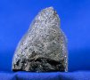Iron Ore (hematite, magnetite, taconite)
- Most common metallic element (others: cobalt, nickel)
- 4th most common element in the Earth (mainly in the core)
- 98% used to make steel
- Largest producers are Russia, Brazil, China, Australia, India, USA
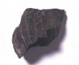Oil Shale
- Contains feldspar, quartz, mica, pyrite, organic matter
- ¾ of sedimentary rock on Earth’s crust
- World’s largest reserve under NW Colorado
- Extract oil; slate for paving and roofing
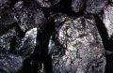Coal
- 4 types: lignite, subbituminous, bituminous, anthracite
- Formed from compressed plant material
- One of the world’s major energy sources (23% of all energy consumed and more than half of electrical energy in the USA)

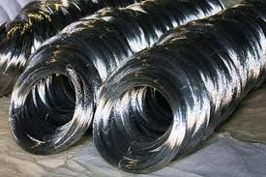Steel
- Made from iron ore, limestone, and coal alloyed (covered) with carbon to strengthen it
- For building, transport, electronics, medicine, paint, ink, cosmetics, fertilizer
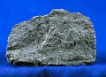Basalt
- Formed from lava from a volcano
- Underlies more of the earth’s surface than any other rock
- Largest producers India, Russia, Iceland, Canada, China, USA
- Used for road base, in concrete, railroad ballast, filter stone in drain fields, floor tiles, monuments
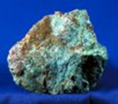Copper
- Lead producers Chile, USA, Indonesia
- Malleable (can be hammered and molded into shapes) and ductile (drawn into wire)
- Used for electrical wiring, electronics, plumbing, tubing, machinery, coatings, coins, feed, fertilizer
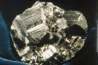Pyrite
- Used as jewelry, to manufacture sulfuric acid and sulfur dioxide, pellets of pressed dust used to recover iron, gold, copper, cobalt, nickel
Many thanks to SME’s MEC for the activity, information, and supplies. To learn more and access free educational material, visit www.MineralsEducationCoalition.org.

