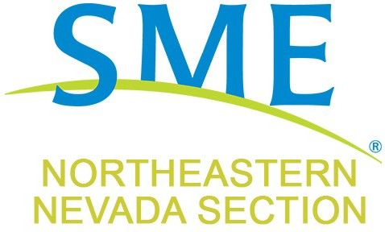

Society for Mining, Metallurgy & Exploration

Join us for a Social Meeting

When: Thursday August 11, 6 – 8 PM

Where: Dreez – 405 Silver Street, Elko

This meeting will be a Social Gathering No speaker

Come down to socialize and have some food and drinks and play some cornhole out on the Patio
Meeting Sponsor:
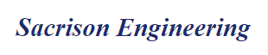
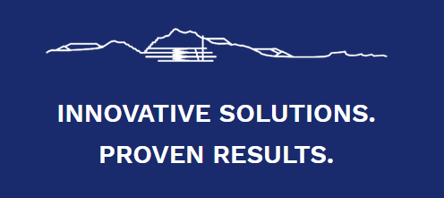

Discuss subcommittees – looking for volunteers
(Community Outreach and Scholarship)

Please RSVP to the Section Email listed below. Walk-ins always welcome, but a head count helps in preparation for the evening.

Volunteer – Present talks – Sponsor meetings

