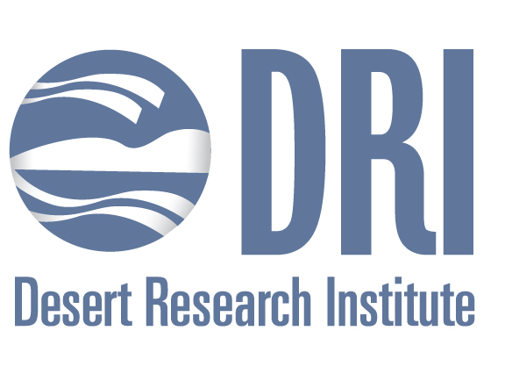

Overview and Outcomes from the Governor’s Recent Trade Mission to Australia

Alan Gertler, Ph.D.
Vice President for Research
Desert Research Institute

During the great recession, the Nevada economy was among the hardest hit of any state in the US. Among the reasons was an economy with a heavy reliance on tourism and relatively narrow base focused on gaming, sales, mining, and property taxes. This has led to periods of “boom and bust”. To change this cycle, the Governor has implemented a number of strategies to enhance existing industries (e.g., mining) and develop new industries (e.g., autonomous vehicles and water technologies). One of the components of this effort has been conducting foreign trade missions to recruit companies to move to Nevada and enhance partnerships with entities outside of the state in order to enhance and grow existing industries.

Recently the Governor conducted a trade mission to Australia. This mission emphasized our mining, water technology, and higher education sectors. As part of this talk, I’ll present an overview of the trip and discuss some of the unique outcomes linking mining education that have the potential to change how mining professionals are trained.

