Availability of Public Lands to Mining and Mineral Exploration
July 21, 2020
Issue
- Minerals produced on public lands are vital to United States’ economic growth, national defense, energy security, and critical infrastructure needs.
- The federal government often withdraws or restricts mineralized areas on public lands from such development without conducting comprehensive resource inventories and mineral-resource assessments.
- Without such inventories or resource assessments, the governmental withdrawals may permanently bar the development of minerals essential to U. S. economic and national security.

Background

The United States has a wealth of minerals and has reserves of more commodity minerals and metals (78) than any other country. The current value of select mineral resources in the United States is estimated at $6.2 trillion. U. S. mining has a direct economic impact of $700 billion annually, or about three (3) per cent of U. S. gross domestic product.

According to the U.S. Geological Survey (USGS), $109 billion of coal and minerals were mined in 2018. USGS and the Department of Commerce estimate that industries such as construction and durable goods manufacturing that use process mineral material added $3.0 trillion to the U.S. economy in 2018 – about 15 percent of U.S. GDP. More than 1.5 million American jobs are directly supported by coal and minerals mining. Taxes, fees and royalties paid by mineral producers generate significant revenues for state, federal and local governments. In fact, the federal government receives more than $12 billion annually in revenues from the extraction of minerals on federal lands and waters and Native American lands.

Minerals found on public lands are essential to our daily lives:

  - Energy security – Coal, oil, gas, and uranium are among the minerals used to meet the bulk of the United States’ energy needs, from motor fuels to home heating and electricity.
  - Renewable Energy - Wind and solar require copper, molybdenum, rare earth elements, silver, cement, and steel.
  - Manufacturing – Copper, iron, zinc, and lead are, for example, used in the manufacture of everything from wires to batteries to motor vehicles.
  - Food Supply and Agriculture – Fertilizers and other products vital to agriculture contain sodium, potash, and phosphate.
  - Infrastructure – Construction materials, including limestone and aggregates, are essential mineral commodities in the construction and maintaining of roads, sidewalks, railroads, and bridges.
  - National Defense – Critical minerals, including rare earth elements and uranium, provide key components in the manufacture of military aircraft and other equipment.

The U.S. Bureau of Land Management (BLM) and the U.S. Forest Service administer mineral resources on more than 640 million acres of public lands, or about 28% of the 2.27 billion acres of land in the entire United States. Most of these lands are in 11 western states and Alaska (as of September 30, 2018). The amount of federally owned land varies from state to state, ranging from 0.3% of land in Connecticut and Iowa to 80.1% in Nevada. Of the 640 million acres, 167 million have been withdrawn, and another 182 million acres are restricted from future development. BLM manages both surface and mineral rights of its public lands domain. BLM manages its surface and mineral rights, while other agencies manage only the surface (Fig. 1).

Western states account for 75% of our nation’s metals production. As such, the availability of Federal lands for mineral exploration and development is critical to maintain a strong domestic mining industry.

A comprehensive range of federal and state laws and regulations address the environmental impacts of mining on Federal lands. These create a rigorous set of mining and reclamation standards for the domestic exploration and mining industry that are emulated world-wide.

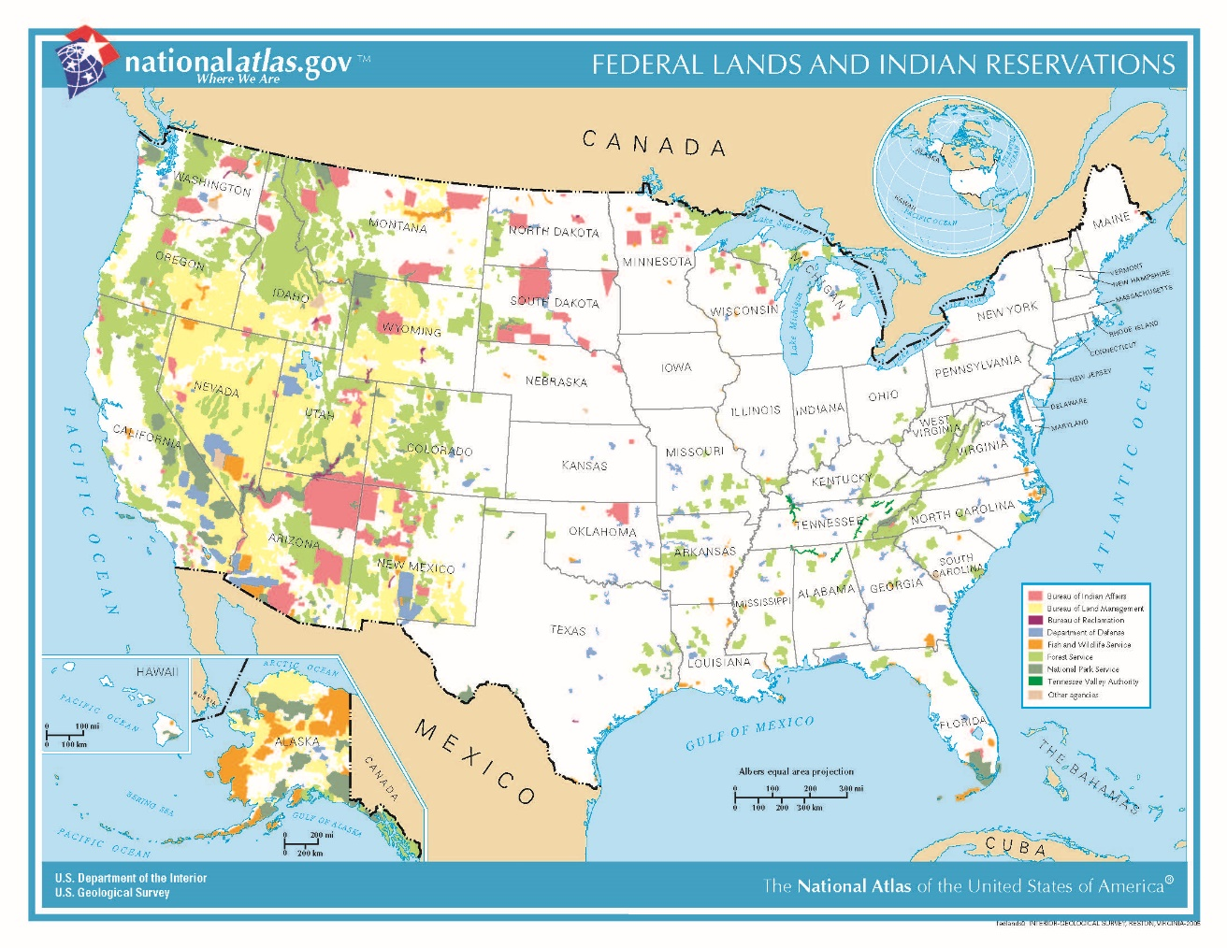

FIGURE 1. Federal lands in the United States (from USGS National Atlas of the U.S.).

SME Statement of Technical Position

- Availability of public lands provides the United States the opportunity to find and produce economic minerals, which is important to offset foreign mineral dependence, decrease a growing trade deficit, create skilled jobs, create wealth, and help solidify the nation’s economic security.
- A thorough geological and economic assessment, including mineral inventory and mineral-resource assessment, should be made before any land is even considered for withdrawal, disposition, or transfer.
- Given the lack of current and recurring mineral-resource assessment of many withdrawn areas, it is uncertain what minerals, and in what quantity and quality, occur on Federal lands. Periodic reassessments should be made of these lands utilizing new geologic and mineral resource data.

There are four principal types of land withdrawals: 1. Administrative withdrawals are made by the President, Secretary of the Interior, or other authorized Executive branch officers. Examples include Executive Orders, Presidential Proclamations, Secretarial Orders, Public Land Orders, Departmental Orders, U.S. Geological Survey Orders, and Bureau of Land Management (BLM) Orders. Currently, only public land orders signed by the Secretary or Assistant Secretary of the Interior are used for administrative withdrawals. However, the President still has authority to make emergency withdrawals. 2. Presidential Proclamation withdrawals are made by the President pursuant to the authority under the Antiquities Act of 1906. The President may use this authority to designate landmarks, historic and prehistoric structures, and other objects of historic or scientific interest. 3. Congressional withdrawals are legislative actions taken by Congress in the form of public laws. Examples include Wilderness designations, creation of National Parks, and Wild and Scenic River designations, among others. 4. FPA or FERC withdrawals are established under the authority of the Federal Power Act (FPA) of June 10, 1920. Such withdrawals are automatically created upon filing an application for hydroelectric power development with the Federal Energy Regulatory Commission or FERC (formerly the FPC). https://www.blm.gov/programs/lands-and-realty/land-tenure/withdrawals
Based on USGS estimated reserve base and USGS estimate of undiscovered deposits for the following mineral commodities: iron ore, copper, niobium, cobalt, gold, molybdenum, rare earths, silver, potash, bauxite, graphite, lead, zinc, mercury, strontium, sulfur, talc, magnesite, kaolin, lithium. Data sources: USGS Mineral Commodity Summaries (2020); Platts Metals Week (January 4, 2010); USGS 1998 Assessment of Undiscovered Deposits of Gold, Silver, Copper, Lead, and Zinc in the United States (Circular 1178).
Facts about Coal and Minerals at 3, National Mining Association (2020).
Id., at 4-5.
Natural Resources Revenue Data, U. S. Department of the Interior, Office of Natural Resources Revenue, https://revenuedata.doi.gov/?tab=tab-revenue
https://crsreports.congress.gov/product/pdf/R/R43429/34 and https://crsreports.congress.gov/product/details?prodcode=R43429.

