Considerations of Large Diameter Idler Rollers on the Indentation Rolling Resistance for Designers of Belt Conveying Systems

Shawn Ryan¹, Jayne O’Shea², Tiago Cosseau^{3,4}

¹ Big Roller™ Overland Conveyor Company, 7 Southport street, West Leederville, WA.

² TUNRA Bulk Solids, 70 Vale Street, Shortland 2307, Australia.

³ Federal University of Technology of Parana, Brazil

⁴ The Centre for Bulk Solids and Particulate Technologies, The University of Newcastle, Australia

ABSTRACT Big Roller™ Overland Conveying Company has implemented a systems engineering approach that addresses the design, fabrication, installation and operation of overland belt conveying systems. In these systems, indentation rolling resistance represents a significant component of the overall energy loss. To reduce indentation rolling resistance and other losses, it is known that larger idler roller diameters can be used. Thanks to advancements in composite materials, it is now possible to produce belt friendly rollers that meet Occupational Health and Safety targets for roller weights whilst simultaneously increasing the diameter beyond what is conventionally available in the market. This paper presents results from measurements of indentation rolling resistance using idler rollers with diameters of 152.4 mm, 219 mm, 316 mm and 400 mm to evaluate the impact of larger diameter rollers on energy savings for the Big Roller™ design configuration used to convey Primary Crushed Iron Ore. The paper also discusses the considerations for designers of long conveyor systems for bulk material movement more generally.

Introduction

Belt conveying systems have traditionally utilised carry side rollers with diameters ranging between 152 mm and 219 mm, with some manufactures producing rollers up to 250 mm in diameter. These rollers were typically fabricated using Electric Resistance Welded (ERW) tube for the shell and pressed mild steel for endcaps. However, recent advancements in materials science have led to the emergence of new belt friendly designs and materials of construction. The roller market now offers a variety of shell and end cap materials, including High Density Polyetheylene, Polyproylene, Nylon and Ultra High Molecular Weight Polyelthylene, often with additives such as Glass Fibre, Carbon Fibre or Carbon Black. These alternative materials make it possible to push the conventional boundaries of upper limits on roller diameter whilst still maintaining lighter weights that align with occupational health and safety targets.

Indentation Rolling Resistance (IRR) can account for as much as 60% of the total energy consumption in overland conveying systems []. Additional primary losses are attributed to rim drag (bearing friction and seal drag), material and belt flexure, and idler alignment []. Using larger diameter idler rollers increases the contact area between the belt and roller, reducing contact stresses, and hence reducing IRR. Moreover, the larger radii and smaller angular velocity of the idler results in lower rotating resistance and reduced seal drag in the bearings and labyrinth seals. This paper presents the impact of idler diameter on efficiency within a Big Roller™ overland conveyor design for Primary Crushed Iron Ore operating at 25 Million Tonne Per Annum and discusses considerations for designers.

Experimental Procedures, Methods and results

A conveyor belt sample was installed on the IRR test facility, which is operated by TUNRA Bulk Solids at The University of Newcastle, Australia and tested in accordance with Australian Standard AS 1334.13 [] to investigate the impact of idler roller diameter on IRR. Experiments were conducted using four different test idler sizes at three different operating temperatures for a range of belt loads

FH_{total} represents both IRR and belt flexure resistance (N/m). For the conditions tested, the measured results indicate a substantial benefit in using larger rollers, with reductions of FH_{total} by over 40% observed between 152 mm and 316 mm. Further details and analysis of the test results are provided in [].

To account for the belt flexure force component included in the FH_{total} measurement, post processing of the data in accordance with curve fit methods described in [] was performed. The curve fit data is then presented in charts for various parameters, as illustrated in Figure 1 and Figure 2.

Figure 1 Horizontal Force for various belt loads at velocity 5 m/s, sag ratio 1 %

The form of the curves are presented as the following equation.

${FH}_{total}=A+B{∙F}_{n}^{c}$ ( 1 )

Where,
A represents belt flexure (N/m)
B represents a multiplyer dependent on velocity (N/m)^{1/3}
F_{n} represents the normal force applied to the belt (N)
c is an exponent with value 4/3
and thus by decomposition of terms, IRR force F_{IRR} can be derived as

$F_{IRR}=B{∙F}_{n}^{c}$ ( 2 )

Figure 2 B Coefficients at various velocities, sag ratio 1 %

It is of note that a resonance was observed to occur at 6 m/s during testing which can cause results to be somewhat spurious in this region. For further analysis herein, a linear relationship is assumed between B coefficients across the velocity range typically found on conveyors to account for this.

TEsTing Considerations

An update to AS1333 [] is proposing the inclusion of IRR testing to determine the energy efficiency performance of belt compounds. The update includes two types of tests. Type I testing allows for comparative testing between compounds on standard belts to determine an energy efficiency rating for belt cover compounds and Type II allows for specific testing of a design case and belt manufacturers construction.

Previous studies have indicated that steel corded belt construction plays a significant role in determining the magnitude of the IRR []. As a recommendation for Overland Conveyor designers, the author suggests using Type I testing for competitive assessment of compounds and utilising Type II testing to determine the IRR values used in design calculations for specific conveyor design parameters, including idler diameters under consideration. Type II testing is especially relevant for new overland conveyors with variable speed drives that operate at variable speeds, loads and sag.

Currently there are some limitations with the existing TUNRA test rig that will need upgrading to meet the Big Roller™ testing requirements. The roller mounting frame on the current test rig is limited to testing of diameters less than 400 mm. To achieve compliance with Section 5.2 of AS 1334.13, which states that the drive pulley, take-up pulley, idler rolls and test idler roll shall support the belt in the horizontal plane to within ±0.5 mm of alignment, larger pulleys, minor structural modifications and a new measurement frame will be required.

Design Considerations

Presented below are the major considerations that designers can optimise with respect to idler diameter, to achieve energy efficient overland conveying.

Indentation Rolling Resistance

IRR can be determined by two general approaches, namely the small sample method or the large sample method, as described in CEMA []. To calculate the IRR for an idler station, the normal force distribution across the idlers needs to be predicted. This can be calculated using either the normal force from a static load analysis method or the dynamic load analysis method which takes into account the normal forces from the belt and bulk material flexure as outlined in [], wherein both derive

$F_{ind}=F_{ind, c}+2.F_{ind,s }$ ( 3 )

It is suggested that the dynamic method presented in [9] provides a more accurate representation when compared to other IRR models, however several assumptions are necessary to apply this model to a Big Roller™ dual centre roll design. Further field and analytical testing is required for its application.

Rim Drag

Rim drag of an idler roller can be separated into three main areas presented below. Typically the total rim drag will be the combination of these component forces.

Labyrinth seal viscous Drag

Recently, the labyrinth seal viscous drag equations in the application of conveyor idlers have been updated to consider grease apparent viscosity instead of base oil viscosity []. Axial seal arrangements described in [10] derive torque as follows.

$T_{a}=\left[τ_{y}+K{\left(\frac{ω\overline{r}}{b}\right)}^{n}+η_{∞}\left(\frac{ω\overline{r}}{b}\right)\right]2πR_{0}^{2}L$ ( 4 )

And radial seal arrangements described in [10] derive torque as follows.

$T_{r}=2π\left(\frac{R_{o}^{3}-R_{i}^{3}}{3}\right)\left[τ_{y}+\frac{3K}{3+n}{\left(\frac{ωR_{o}}{b}\right)}^{n}\left(\frac{1-{\left(\frac{R_{i}}{R_{o}}\right)}^{3+n}}{1-{\left(\frac{R_{i}}{R_{o}}\right)}^{3}}\right)+\frac{3η_{∞}ωR_{o}}{4b}\left(\frac{1-{\left(\frac{R_{i}}{R_{o}}\right)}^{4}}{1-{\left(\frac{R_{i}}{R_{o}}\right)}^{3}}\right)\right]$ ( 5 )

Contrary to this, Bosch et al. [], based on several experiments, indicate that over time, the friction on the labyrinth seals will tend to zero as an air gap develops between sealing components.

rolling element bearing friction

The SKF method [] is used to derive moments for deep groove ball bearings. The total friction moment of each bearing M_{bearing} can be obtained by

$M_{bearing} = M_{rr} + M_{sl} + M_{seal} + M_{drag }$ ( 6 )

where M_{rr} is the rolling frictional moment, M_{sl} is the sliding frictional moment, M_{seal} is the frictional moment of seals and M_{drag} is the frictional moment of drag losses. The friction moment of seals and drag losses are zero for shielded (ZZ) grease-lubricated rolling bearings typically used in idlers of conveyor belts. A designer needs to calculate M_{rr} and M_{sl}.

According to SKF the Power loss is

$P_{loss}=1.05×{10}^{-4}∙M_{bearing}∙n$ ( 7 )

where n is in RPM.

LIp Seal Resistance

The force acting due to the resistance to rotation of the lip seal F_{lipseal}, is approximated by

$F_{lipseal}=\frac{0.3 e^{(0.25d_{ls})}⁡}{D}$ ( 8 )

where d_{ls} is the contact diameter of the lip seal. It can be seen that lip seal forces are directly proportional to roller diameter. Anecdotally, idler manufacturers note that friction on the lip seals within idler sealing arrangements will also tend to zero over time as the contact face wears.

Other Primary losses

Further losses in conveyor systems are related to idler skew losses, derived from manufacturing tolerance misalignment, installation misalignment and idler tilt, as well as Belt and Bulk Material Flexure Resistance. These losses will not be discussed as they are unrelated to idler diameter.

Application to the Big Roller™ Design

Big Roller™ has developed a ground (low or mid) level module design that incorporates the idler station rigidly fixed within the supporting legs of the module. The design incorporates fixed, non-pivoting, dual centre rolls at each idler station. Each carry roll has a diameter of 508 mm and are nominally 20 kg in weight. Each carry roller will have total indicator runout below 0.2 mm and be balanced to ISO 211940-11:2016 Grade G16. Return rollers have a diameter of 178 mm and are nominally 20 kg in weight, balanced to ISO 211940-11:2016 Grade G40. Each roller shaft mounting slot within the idler station frame is one-pass machined to ensure very tight fabrication tolerances. The module design is presented in Figure 3 and Figure 4.
.

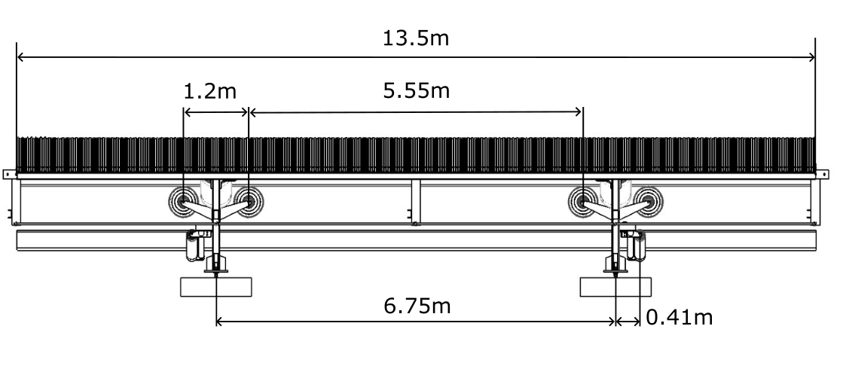
Figure 3 Big Roller ground (low and mid) level module design parameters

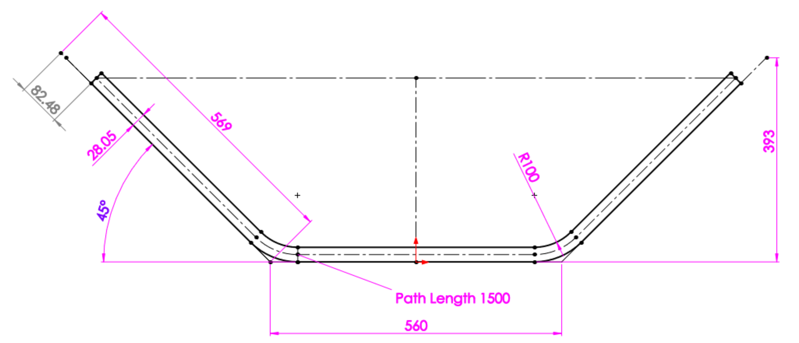

Figure 4 Big Roller 1500BW 45° cross sectional profile with 569 mm equal roller length and 560 mm length between Intersection Points.

The conveyor design parameters for a typical Big Roller™ Iron Ore conveying system are detailed in Table 1.

Table 1 Big Roller™ Iron Ore conveying system design parameters

Parameter | Value
Belt capacity nominal | 25 MTPA / 40 MTPA
Annual operating hours | 6500
Tonnes per hour | 3846 / 6150
Velocity (m/s) | 4 / 6.4
Surcharge angle | 20° (range 0, 10, 20)
Density (t/m³) | 1.7 (range 1.4 - 2.4)
Belt Width (mm) | 1500
Belt Mass (kg/m) | 81
CEMA edge distance (mm) | 105.5
Primary crushed edge clearance (50% max Particle Size Distribution 350mm (mm) | 175
Edge Clearance at 4 / 6.4 m/s (1.7 t/m³, 20° surcharge) | 245

For comparison a conventional 45 degree, 3 roll carry idler set using 178 mm diameter rollers with a 2.25 m span has also been considered over a 13.5 km long conveyor. Table 2 presents idler and roller quantities.

Table 2 13.5km overland parameter comparison

Parameter | Big Roller™ design | Conventional design
Number of idler stations | 2,000 | 6,000
Number of carry rolls | 8,000 | 18,000

Indentation rolling resistance

There are two approaches that a designer can utilise for calculating normal loads on idler rollers. The first is where the velocity is adjusted to suit the desired cross sectional area and edge clearance to achieve the required tonnage rate. The second is where the velocity is set constant and the cross sectional area is adjusted against density to achieve the required tonnage rate. The latter is presented below. For the purpose of relative demonstration, the 152 mm and 400 mm, 0°C B coefficients (Figure 2) at 5 m/s are presented due to limited availability of empirical test data.

Using the variable cross section method and calculating the IRR force, F_{ind, total}, with the method outlined in Section 3.1, yields the results presented in Figure 5 for the Big Roller™ dual centre roll (BR™) and a conventional 3 roll (single) design configurations. It should be noted that the analysis of static normal idler forces has been presented and for simplicity each centre roll is assumed to be equally load sharing.

Figure 5 Individual idler station IRR loads at 400mm diameter, 5m/s and 0°C

Table 3 presents the total IRR for a 13.5 km example case assuming a belt speed of 5 m/s, a 20° surcharge angle and bulk material density of 1.7 t/m³ typical in Iron Ore bulk materials handling.

Table 3 13.5 km overland IRR comparison

Parameter | Big Roller™ design (400mm) | Conventional design (152mm)
IRR / Idler station (N) | 30.97 | 46.77
Total IRR (kN) | 61.94 | 280.62

It is worth consideration that although a higher tension is required to maintain a belt sag ratio of 1% over the larger Big Roller™ idler station span, for longer distances the effective tension at the head end of the system can be reduced due to the impact of lowering the IRR. This means a smaller turndown ratio between maximum and minimum tension is possible and can change outcomes for selected splice factor of safety or ST rating of steel cord belts.

Rim Drag

Typical limits on Rim Drag specified within the Iron Ore industry are outlined below in Table 4.

Table 4 Typical Rim Drag specification limits for 20°C at 4m/s

Bearing size | 152mm (N/idler) | 178mm (N/idler)
6308 | 3.6 | 3.4
6309 | 4.1 | 4.0

Across the design belt speeds, angular velocity decreases with increased diameter. Load is increased when the span between idler stations increases. The increase in load with the Big Roller™ design is offset through the addition of a second central roll and thus, it can be shown that the 6309 bearing size can be maintained for a prescribed L₁₀ bearing life (65,000 hrs) and shaft deflection limits (8 mins). With this being the case, a sealing design (radial or axial) used on a 178 mm shell can be maintained for the 508 mm shell design. A designer could therefore simplistically consider rim drag as being directly proportional to the diameter.

Using the SKF model, [] presents the Total Frictional Moment for a 6310 bearing against rotational speed, mean diameter and dynamic viscosity, Figure 6.

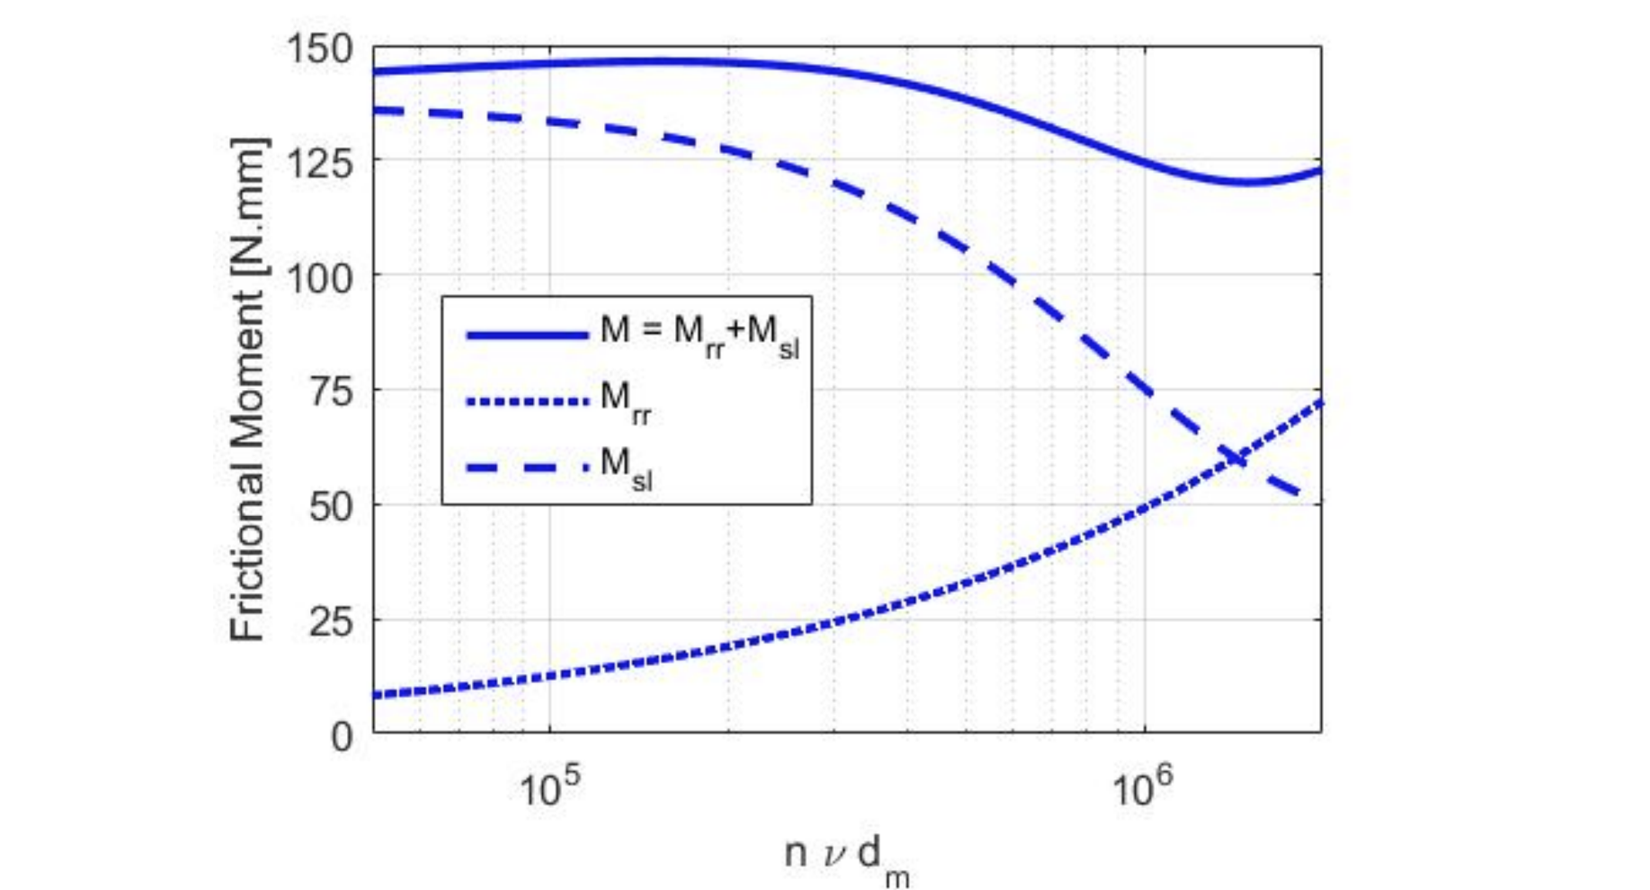

Figure 6 Typical rolling and sliding components of total Frictional Moment [13]

Again, the total frictional moment could be read by a designer at each respective rotational speed, however it should be noted that due to reduction in angular velocity with increasing diameters, grease specifications for slower rotational speeds associated with the Big Roller™ design will require a higher base oil viscosity (100 cST), different thickener types and potentially extreme presssure additives when compared to traditional idler grease specifications (50 cST) to minimise the frictional moment. The consideration to viscosity can be observed in the Figure 7.

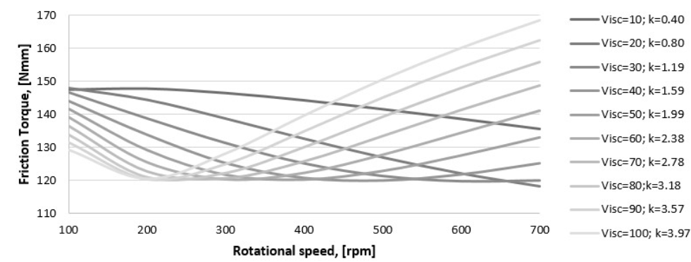

Figure 7 Frictional Moment for different lubrication conditions []

Specific consideration should be given by idler designers and manufacturers to ensure that the calculated lubricant life (L_{mh}) in accordance with ISO 281 is equal to or greater than the L₁₀ bearing life. Idler bearings and seal power loss across a range of grease types are currently being tested at TUNRA on the test rig shown in Figure 4 & 5 of []. The test rig is being upgraded to be suitable for larger loads and will review earlier work in this area with several grease types, rotational speeds, temperatures and loads.

Taking a conservative approach, Table 5 presents the assumed individual and cumulative rim drag force on an example 13.5 km conveyor.

Table 5 13.5 km Overland Conveying System – Rim Drag Comparison

Parameter | Big Roller™ design (508mm) | Conventional design (178mm)
Rim Drag / Roller (N) | 4.0 | 4.0
Total Rim Drag (KN) | 32 | 72

Discussion

In agreeance with IRR models, larger rolls have been shown to substantially reduce IRR both on an individual roller and total conveyor basis. A designer can use a simple static normal force distribution to ascertain a distinguishing impact for idler station span and roller diameter. As most overland conveyors in the Australian Iron Ore market carry predominantly primary crushed material, to provide a more accurate representation, further analytical work is required to determine the validity of the normal force distributions that includes belt and material flexure dynamics on offset dual centre roll idlers. Test work to determine the internal friction and material to belt friction parameters of these ores types is also required.

When considering Rim Drag, special consideration needs to be made for the selected grease lubricant, particularly its viscosity and thickener type. Idler roll manufacturers need to consider the impact of larger diameters, and the resulting lower angular velocities have on grease selections, particularly power loss and life.

Conclusion

This paper has presented the results of IRR measurements for idler rollers with diameters of 152.4 mm, 219 mm, 316 mm, and 400 mm, as well as considerations for overland conveyor designers regarding the proposed update to AS1333. The importance of energy loss considerations in selecting a roller diameter has been highlighted. A case study for the Big Roller™ Overland Conveyor Company module has been presented, and comparisons have been made between this and a 3-roll carry idler station at conventional idler spans used in the Iron Ore Industry. The results demonstrate that larger idler rollers can significantly reduce both IRR and Rim Drag, and the Big Roller™ design has optimised these efficiencies through its idler station arrangement. A 13.5 km example overland conveyor using the Big Roller™ design has shown a reduction in both IRR and Rim Drag. The introduction of the Big Roller™ Overland Conveyor Company module presents an opportunity for designers to improve energy efficiency in their conveyor systems. This study provides valuable information and insights for designers and engineers working on overland conveyor systems.

Acknowledgements

The Authors would like to acknowledge that they are grateful for the valued contributions of Stephan Hoette and that this research was undertaken by TUNRA and the belt and datasets for 152 and 219mm diameter rollers was supplied by ContiTech Australia Pty Ltd.

NOMENCLATURE

Equation (3)
F _{Ind} Indenatation force (N)
F _{Ind,c} Indenatation force for centre roller(s) (N)
F _{Ind,s} Indenatation force for wing roller (N)

Equation (4) & (5)
b the gap at the labyrinth seal (mm)
K grease consistency index
n power-law index
$\overline{r}$ average radius between the two concentric cylinders (m)
R_{o} labyrinth seal outer radius (m)
R_{i} labyrinth seal inner radius (m)
T_{a} axial torque (Nm)
T_{r} radial torque (Nm)
t_{y} grease yield stress (Pa)
w rotational speed (revolutions / second)
$η_{∞}$ infinity shear rate viscosity (Pa.s)

References

Hager, M. and A. Hintz, The energy-saving design of belts for long conveyor systems. Bulk Solids Handling, 1993. 13(4): p. 749-758
Wheeler C, Analysis of the Main Resistances of Belt Conveyors, PhD Thesis. University of Newcastle, 2003
Australia, S., AS 1334.13:2017 Methods of testing conveyor and elevator belting Determination of indentation rolling resistance of conveyor belting. 2017, Standards Australia.
O’Shea, J. et.al., The Effect of Large Diameter Idler Rollers on the Indentation Rolling Resistance of Belt Conveying Systems. ICBMH, 2023
Munzenberger, P. and Wheeler, C. Laboratory measurement of the indentation rolling resistance of conveyor belts, Measurement: Journal of the International Measurement Confederation Vol. 94, Issue December 2016, p. 909-918
Australia, S., AS 1333:1994 Conveyor belting of elastomeric and steel cord construction. 1994, Standards Australia
Wheeler, C. Munzenberger, P. Predicting the Influence of Conveyor Belt Carcass Properties on Indentation Rolling Resistance, Bulk Solids & Powder: Science & Technology Vol. 4, Issue 2, p. 67-74
CEMA: Belt Conveyors for Bulk Materials, 7th Ed. 2014.
Wheeler, C. Munzenberger, P. Ausling D. and Beh, B. Energy efficient belt conveyor design, International Materials Handling Conference (BELTCON'18). International Materials Handling Conference (Johannesburg, South Africa 5-6 August, 2015) p. 1-27
Augusto, L. Takahama M. Negrao C. and Cousseau T. The effect of viscous dissipation and heat transfer on friction losses of grease-filled labyrinth seals Tribology International 2021
Bosch F. and Haas W. Sealing of Dry Particles with Grease-Filled Non-Contacting Sealing Systems, Lubricants 2017, 5, 38
SKF Rolling bearings catalogue pdf, page 135 website 0901d196802809de-Rolling-bearings---17000_1-EN_tcm_12-121486.pdf (skf.com)
Borges, B. Performance analysis of rolling bearing in conveyor belt idlers, Masters disceratation, PPGEM, 2020.
Tiago Cousseau, T. Borges, B. Pritzelwitz, P. da Fonseca, R. Performance-based design: Case study of conveyor belt idlers. 13th International Conference on Bulk Materials Storage, Handling and Transportation 2019
Wheeler, C. Rotating resistance of belt conveyor idler rolls. Journal of Manufacturing Science and Engineering Vol. 138, Issue 4

