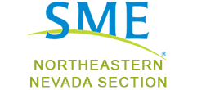

Join us for drinks, snacks and a technical talk!

When: Thursday, March 14th, 6:30-8:30pm
Where: Red Lion Casino, Elko

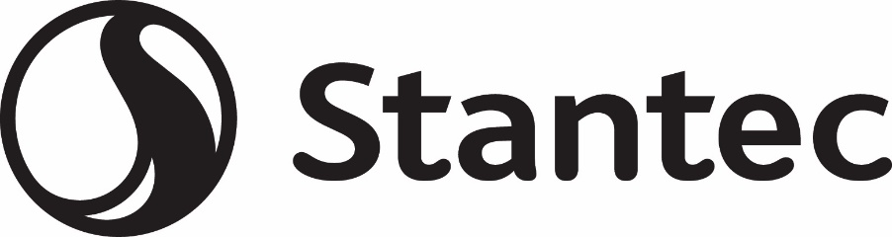

Meeting Sponsors: Stantec
Meeting Speaker: Julian Fisher
Meeting Topic: Underground Mine Uses of Electricity – How to Ensure Your Infrastructure is Up to the Task

For further information, please contact:
Brianna Drury, 775-385-4113
Julia Schmidt, 775-401-0149

