MAY MEETING – Thursday, May 9, 2019

“Ore Control in the Modern Mining Era – Are We Doing Enough?”

PRESENTED BY: Jennifer Baar, SME Henry Krumb Lecturer
TIME: 6:00 pm Social  7:00 pm Dinner and Presentation  LOCATION: Dave & Buster’s Conference Room  4821 Mills Circle  Ontario, CA 91764 | 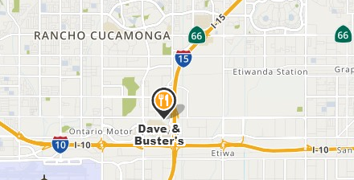
COST: RSVP - Professional $35, Students $10  At door - Professional $40, Students $20 | RSVP: Nicolette Grill @ ironmtn2012@gmail.com  by Monday ,May 1, 2019
ABSTRACT: Ore control is an important player in the success of a mine. Ore control geologists and/or engineers maximize the economic metal value of a mine. Without a dedicated role committed to the success and progress of an ore control program, it is unlikely a program will be able to stay current on industry-leading trends in technology and best practices. With the mining industry rapidly changing around us, it would appear ore control is being left in the dust. Many of the practices used today are decades-old and have not been revisited in many years. Ore control should be used for more than just a tool to delineate ore and waste. It should be used to assist in short-range mine design, development drilling, metallurgical and material designation, and blast-pattern design, among other purposes. How do we prevent ore control and the people who run the program from becoming obsolete in an ever-changing industry?

BIOGRAPHY: Jennifer Baar, Ore Control Geologist for Rio Tinto, received her BS in Geology from the University of Georgia. She briefly worked in the Environmental Sector until she returned to school for her MSc in Geology from Washington State University. In 2010, she began working full-time for the mining industry with an underground focus in Elko, Nevada, with Newmont Mining Corporation, and later at Barrick Gold Corporation. During her time in the gold industry, she focused primarily on Carlin Style Gold Mineralization in both the Carlin and Eureka-Cortez Trends. In 2015, she moved to an open pit geology role. Currently, she works for Rio Tinto at Bingham Canyon as an ore control geologist.

HOSTED BY: SME SoCal Section, Inland Geological Society, and Association of Environmental and Engineering Geologists

