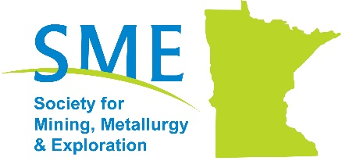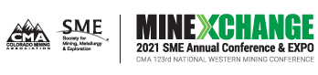

2021 SME Annual Conference & Expo and CMA 123rd National Western Mining Conference

The MN Section of the Society for Mining, Metallurgy and Exploration (SME) is pleased to offer financial support to participate in the 2021 SME Conference & Expo to be held online from March 1-5, 2021. This opportunity is available to MN Section and Subsection Members.
https://www.smeannualconference.com/

To be eligible, applicants will also need to provide a summary of the events they attended and the contacts they made representing SME MN Section and/or their SME MN Subsection. Individuals selected will be required to register for the conference and pay for the events, then request reimbursement from the MN Section for the awarded funding amount by March 12, 2021. Receipts are needed to receive reimbursement. The award is eligible for offsetting costs for registration for the selected individual to attend the conference proceedings and reimbursement will be limited to registration costs. Reimbursement from the MN Section will not include wages, lost time off from work, entertainment expenses, silent auction bids, or SME promotional/educational material purchased at the conference.

Individuals that apply for support for the conference registration are required be a current paid member of SME and aligned with the MN Section because they live/work in Minnesota. The individual need not be currently active within the MN Section, Twin Cities Subsection, or Northern MN Subsection to apply for financial support. Please fill out the attached application to determine an applicant’s eligibility.

All applications must be submitted by January 20th, 2021.
Selection will be made by January 21st, 2021 to allow attendees to register for early bird rates

For more information please contact the MN Section at: mnsectionsme@gmail.com

Name:
Email:
Phone:
Employer/Organization:
Do you work or live in the MN Section service area?
☐ Yes, I work or live in MN or one of the 9 counties in Wisconsin (Barron, Bayfield, Burnett, Douglas, Dunn, Pierce, Polk, Rusk, Sawyer, St. Croix, and Washburn)
☐ No, I do not.

Have you verified with your company that you can have the time off, if selected? *
☐ Yes, I confirmed this with my company.
☐ No, I have not and I know that this means that I DO NOT qualify.

Are you active in the following (select all that apply, although this is for information purposes only; it does not exclude a Member from applying for financial support).*

☐ SME National: Please note committee or board
☐ MN Section
☐ Northern MN Subsection
☐ Twin Cities Subsection

Terms & Conditions for Financial Support: Individuals selected will be required to register for the conference and pay for the events, then request reimbursement from the MN Section for the awarded funding amount by March 12, 2021. Receipts are needed to receive reimbursement. The award is eligible for offsetting costs for registration for the selected individual to attend the conference proceedings and reimbursement will be limited to registration costs. Reimbursement from the MN Section will not include wages, lost time off from work, entertainment expenses, silent auction bids, or SME promotional/educational material purchased at the conference.

Individuals that apply for support for the conference registration are required be a current paid member of SME and aligned with the MN Section because the live/work in Minnesota. The individual need not be currently active within the MN Section, Twin Cities Subsection, or Northern MN Subsection to apply for financial support.
Do you agree to the terms and conditions for financial support described above? *
☐ Yes, I agree to the terms above.
☐ No, I do not agree and this means that I DO NOT qualify.

Submit this application to mnsectionsme@gmail.com by January 20th, 2021

