Maintenance in Transition – The Journey to World Class Maintenance is the 11th mining maintenance management textbook by Paul D. Tomlingson. Drawn from over 40 years of world-wide consulting experience, this classic textbook aims to help achieve and sustain maintenance performance levels that yield consistently reliable equipment and improved mining efficiency. Essential roles and proven actions are explained and illustrated in six realistic, practical phases. Mining professionals at all levels will find this book invaluable in creating a greater maintenance contribution to mining operations.
PHASE 1 – ESTABLISHING IMPROVEMENT NEEDS
01 Targeting World Class Maintenance
02 Assessing Maintenance Performance

PHASE 2 – STABILIZING THE ENVIRONMENT
03 Applying World Class Principles
04 Stating the Plant Production Strategy

PHASE 3 – IMPLEMENTING THE PROGRAM
05 Developing the Maintenance Program
06 Identifying Roles of Key Personnel
07 Implementing Preventive Maintenance
08 Utilizing Condition Monitoring
09 Planning Maintenance Work
10 Conducting Maintenance Scheduling
11 Facilitating Component Replacement
12 Implementing Reliability Centered Maintenance
13 Initiating Total Productive Maintenance
14 Establishing Effective Work Control

PHASE 4 – UTILIZING INFORMATION
15 Selecting Information Systems
16 Implementing Information Systems
17 Employing Work Order Systems
18 Utilizing Information

PHASE 5 – ESTABLISHING THE ORGANIZATION
19 Selecting Maintenance Organizations
20 Establishing Maintenance and Reliability Engineering
21 Conducting Maintenance Training
22 Obtaining Materials and Shop Services
23 Determining Workforce Size and Craft Composition
24 Applying Performance Indices
25 Measuring Productivity
26 Conducting Benchmarking Surveys
27 Establishing Cost Control
28 Making Equipment Replacement Decisions
29 Applying Quality Control
30 Utilizing Contractors
31 Managing Projects and Shutdowns

PHASE 6 – SUSTAINING WORLD CLASS ACHIEVEMENT
32 Achieving World Class Maintenance

APPENDICES
Appendix A – Maintenance Terminology
Appendix B – PM and Condition-monitoring Techniques
Appendix C – Maintenance Performance Standards
Appendix D – Duties of Key Personnel
Appendix E – Budgeting Techniques

Book Strategy - There are no world class maintenance organizations. Rather, there are world class mining organizations that include a world class maintenance organization. Maintenance, by itself, is a service-provider. When that service is exceptional, it is made that way because maintenance is operating in an environment that requires it to be exceptional. Maintenance is not a ‘stand-alone’ effort by maintenance. Its success requires the joint supportive and cooperative efforts of all mine departments and the dedicated leadership of mine managers. When these conditions exist the considerable benefits of world class maintenance can be achieved.

Engineering and Mining Journal and Coal Age have published a series of six featured articles based on the book. Tomlingson has published over 100 trade journal articles on maintenance management in Engineering and Mining Journal, Mining Engineering, Coal Age, Plant Engineering, Maintenance Technology, Uptime Magazine, Production Engineering, World Coal, Coal, Better Roads, Public Works, Ski Area Management and PIMA. His short stories have been published in The Monterey County Herald (California), The Vermont Sunday Magazine and The Grand County Gazette (Colorado).
Acknowledgements

Plant Engineering – “The base of Tomlingson’s experience is important. He has the credentials to change traditional thinking both within maintenance and about maintenance. Many consultants come out of industry with knowledge based primarily on their employer’s plant.”

Maintenance Technology – “One of the greats of the maintenance and reliability profession.”

Society of Mining, Metallurgy and Exploration – “Critical ‘big picture’ issues are brought to life, providing ideas and techniques to help solve the maintenance problems you’re grappling with today.”

Book Purchase: $ 95.00/copy. Free shipping in the US. Overseas shipping at cost. PayPal, personal check, bank transfer or bank draft.

Powerpoint: Powerpoint slides are available for all topics in the book. Please inquire.

Professional Courtesy: Upon request you may obtain an e-mail copy of any one chapter or appendix of the book (pdtmtc@msn.com).
Please observe copyright conditions.
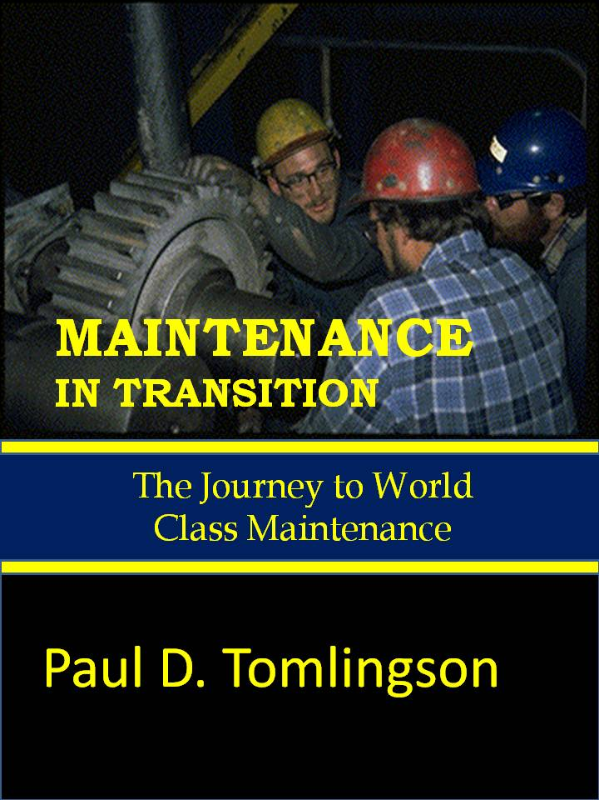

Reviews:

“The definitive what, who, how and why of maintenance management.”
“Shows how to create an environment and culture for maintenance to succeed.”
“Focuses all departments on the essential task of delivering reliable equipment.”
“Valuable to all managers who desire continuous improvement in maintenance operations.”
“All of maintenance is explored and explained with emphasis on practical, use it today advice.”
“Build, train and evaluate maintenance for greatest return in responsiveness and performance.”

